19th International Physics Olympiad

Bad Ischl / Austria

-------------------------------------------------------------------------------------------------------------

Theory 1
Spectroscopy of Particle Velocities

Basic Data

The absorption and emission of a photon is a reversible process. A good example is to be found in the excitation of an atom from the ground state to a higher energy state and the atoms´ subsequent return to the ground state. In such a case we may detect the absorption of a photon from the phenomenon of spontaneous emission or fluorescence. Some of the more modern instrumentation makes uses of this principle to identify atoms, and also to measure or calculate the value of the velocity in the velocity spectrum of the electron beam.

In an idealised experiment (see fig. 19.1) a single-charged ion travels in the opposite direction to light from a laser source with velocity v. The wavelength of light from the laser source is adjustable. An ion with velocity Zero can be excited to a higher energy state by the application of laser light having a wavelength of λ = 600 nm. If we excite a moving ion, our knowledge on Dopplers´ effect tells us that we need to apply laser light of a wavelength other than the value given above.
There is given a velocity spectrum embracing velocity magnitude from 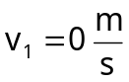 to 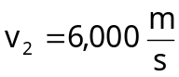 . (see fig. 19.1)

fig. 19.1

Questions
1.1
1.1.1
What range of wavelength of the laser beam must be used to excite ions of all velocities in the velocity spectrum given above ?

1.1.2
A rigorous analysis of the problem calls for application of the principle from the theory of special relativity

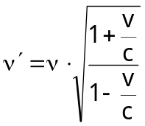
Determine the error when the classical formula for Dopplers´ effect is used to solve the problem.

1.2
Assuming the ions are accelerated by a potential U before excited by the laser beam, determine the relationship between the width of the velocity spectrum of the ion beam and the accelerating potential. Does the accelerating voltage increase or decrease the velocity spectrum width ?

1.3
Each ion has the value 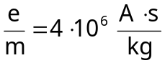, two energy levels corresponding to wavelength 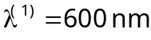 and wavelength 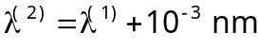. Show that lights of the two wavelengths used to excite ions overlap when no accelerating potential is applied. Can accelerating voltage be used to separate the two spectra of laser light used to excite ions so that they no longer overlap ? If the answer is positive, calculate the minimum value of the voltage required.

fig. 19.2

Solution

1.1
1.1.1
Let v be the velocity of the ion towards the laser source relative to the laser source,
ν´ the frequency of the laser light as observed by the observer moving with the ion (e.g. in the frame in which the velocity of the ion is 0) and
ν the frequency of the laser light as observed by the observer at rest with respect to the laser source.

Classical formula for Doppler´s effect is given as
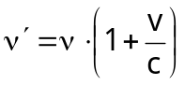 (1)

Let ν* be the frequency absorbed by an ion (characteristic of individual ions) and
ν_{L} be the frequency of the laser light used to excite an ion at rest,
hence:

ν* = ν_{L}

For a moving ion, the frequency used to excite ions must be lower than ν*.

Let ν_{H} be the frequency used to excite the moving ion.

When no accelerating voltage is applied

frequency of laser  light used to  excite ions | magnitude of  velocity of  ions | frequency of laser  light absorbed  by ions | wavelength of  laser light used  to excite ions
ν_{H}  ν_{L} | 0  v = 6 . 10³ m/s | ν*  ν* | λ₁  λ₂

ν_{L} < ν_{H}

ν_{L} = ν*

Calculation of frequency ν_{H} absorbed by moving ions.

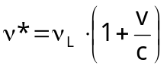 where ν* = ν_{H} = 5 . 10¹⁴ Hz and v = 6 . 10³ m/s (2)

The difference in the values of the frequency absorbed by the stationary ion and the ion moving with the velocity v 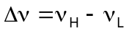
The difference in the values of the wavelengths absorbed by the stationary ion and the ion moving with the velocity v 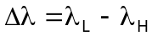
(higher frequency implies shorter wavelength)

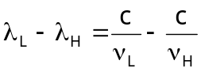
from (2)
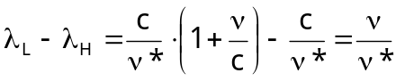
In this case 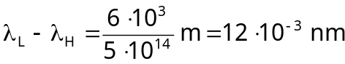

fig 19.3

1.1.2
The formula for calculation of ν´ as observed by the observer moving towards light source based on the principle of the theory of special relativity,
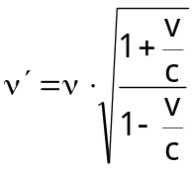
where v is the magnitude of the velocity of the observer towards the light source,
ν´ is the frequency absorbed by the ion moving with the velocity v towards the light source (also observed by the observer moving with velocity v towards the laser source) and
ν is the frequency of laser light as observed by an observer at rest.

(To put in a metaphoric way, the moving ion “sees” the laser light of frequency ν´ even though the scientist who operates the laser source insists that he is sending a laser beam of frequency ν).

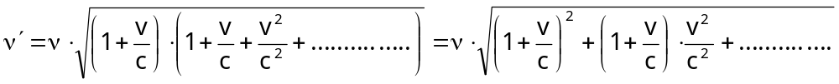

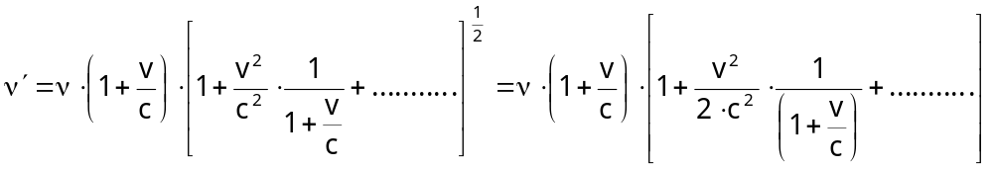

The second term in the brackets represents the error if the classical formula for Doppler´s effect is employed.
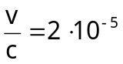

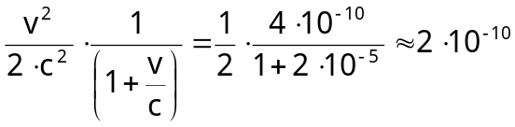

The error in the application of classical formula for Doppler´s effect however is of the order of the factor 2.10⁻¹⁰. This means that classical formula for Doppler´s effect can be used to analyze the problem without loosing accuracy.

1.2 When acceleration voltage is used

frequency of laser  light used to  excite ions | magnitude of  velocity of  ions | frequency of laser  light absorbed  by ions | wavelength of  laser light used  to excite ions
ν_{H}´  ν_{L}´ | v_{H}´  v_{L}´ | ν* = 5 . 10¹⁴ Hz  ν* = 5 . 10¹⁴ Hz | λ_{H}´  λ_{L}´

Lowest limit of the kinetic energy of ions 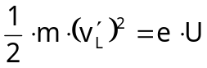 and 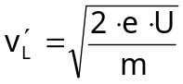
Highest limit of the kinetic energy of ions 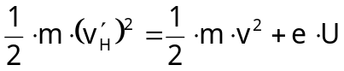
and 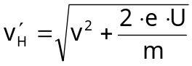
Spectrum width of velocity spectrum 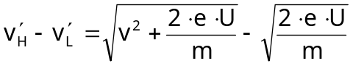 (3)
(Note that the final velocity of accelerated ions is not the sum of v and 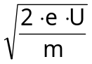 as velocity changes with time).

In equation (3) if is negligibly small, the change in the width of the spectrum is negligible, by the same token of argument if is large or approaches ∞ , the width of the spectrum of the light used in exciting the ions becomes increasingly narrow and approaches 0.

1.3
Given two energy levels of the ion, corresponding to wavelength λ⁽¹⁾ = 600 nm and λ⁽²⁾ = 600+10⁻² nm
For the sake of simplicity, the following sign notations will be adopted:

The superscript in the bracket indicates energy level (1) or (2) as the case may be. The sign ´ above denotes the case when accelerating voltage is applied, and also the subscripts H and L apply to absorbed frequencies (and also wavelengths) correspond to the high velocity and low velocity ends of the velocity spectrum of the ion beam respectively.

The subscript following λ (or ν) can be either 1 or 2, with number 1 corresponding to lowest velocity of the ion and number 2 the highest velocity of the ion. When no accelerating voltage is applied, the subscript 1 implies that minimum velocity of the ion is 0, and the highest velocity of the ion is 6000 m/s. If accelerating voltage U is applied, number 1 indicates that the wavelength of laser light pertains to the ion of lowest velocity and number 2 indicates the ion of the highest velocity.
Finally the sign * indicates the value of the wavelength (λ*) or frequency (ν*) absorbed by the ion (characteristic absorbed frequency).

When no accelerating voltage is applied:

For the first energy level:

frequency of laser  light used to  excite ions | magnitude of  velocity of  ions | frequency of laser  light absorbed  by ions | wavelength of  laser light used  to excite ions
ν_{H}⁽¹⁾  ν_{L}⁽¹⁾ | 0  v=6.10³ m/s | ν⁽¹⁾* = 5 . 10¹⁴ Hz  ν⁽¹⁾* = 5 . 10¹⁴ Hz | λ₁⁽¹⁾  λ₂⁽¹⁾

ν_{H}⁽¹⁾* = ν_{L}⁽¹⁾* = ν⁽¹⁾* = 5 . 10¹⁴ Hz

Differences in frequencies of laser light used to excite ions = ν_{H}⁽¹⁾ – ν_{L}⁽¹⁾
Differences of wavelengths of laser light used to excite ions = λ_{L}⁽¹⁾ - λ_{H}⁽¹⁾

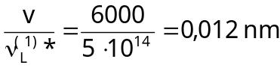

For the second energy level:

frequency of laser  light used to  excite ions | magnitude of  velocity of  ions | frequency of laser  light absorbed  by ions | wavelength of  laser light used  to excite ions
ν_{H}⁽²⁾  ν_{L}⁽²⁾ | 0  v = 6000 m/s | ν⁽²⁾* = 5 . 10¹⁴ Hz  ν⁽²⁾* = 5 . 10¹⁴ Hz | λ_{H}⁽²⁾  λ_{L}⁽²⁾

ν_{H}⁽²⁾* = ν_{L}⁽²⁾* = ν⁽²⁾* = 5 . 10¹⁴ Hz

Differences in frequencies of laser light used to excite ions ν_{H}⁽²⁾ – ν_{L}⁽²⁾
Differences in wavelengths of laser light used to excite ions λ_{L}⁽²⁾ – λ_{H}⁽²⁾
This gives 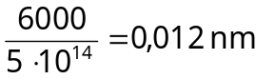

fig. 19.4

Hence the spectra of laser light (absorption spectrum) used to excite an ion at two energy levels overlap as shown in fig. 19.4 above.

When accelerating voltage is applied:

Let λ_{H}⁽¹⁾´ and λ_{L}⁽¹⁾´ be the range of the wavelengths used to excite ions in the first energy level, when accelerating voltage isapplied. (Note the prime sign to denote the situation in which the accelerating voltage is used), and let λ_{H}⁽²⁾´ and λ_{L}⁽²⁾´ represent the range of the wavelengths used to excite ions in the second energy level also when an accelerating voltage is applied.

Condition for the two spectra not to overlap:

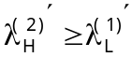 (see fig. 19.4) (4)

(Keep in mind that lower energy means longer wavelengths and vice versa).

From condition (3): 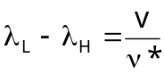 (5)

The meanings of this equation is if the velocity of the ion is v, the wavelength which the ion “sees” is λ_{L}, when λ_{H} is the wavelength which the ion of zero-velocity “sees”.

Equation (5) may be rewritten in the context of the applications of accelerating voltage in order for the two spectra of laser light will not overlap as follows:

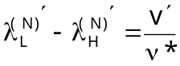 where N is the order of the energy level (6)

The subscript L relates λ to lowest velocity of the ion which “sees” frequency ν*. The lowest velocity in this case is and the subscript H relates λ to the highest velocity of the ion, in this case 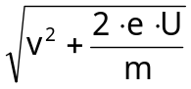.
Equation (6) will be used to calculate
- width of velocity spectrum of the ion accelerated by voltage U
- potential U which results in condition given by (4)

Let us take up the second energy level (lower energy level of the two ones) of the ion first:

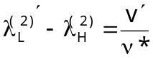 (7)
substitute
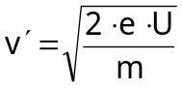
λ_{H}⁽¹⁾ = 600 + 10⁻³ nm
v* = 5 . 10¹⁴ Hz
v = 0 m/s

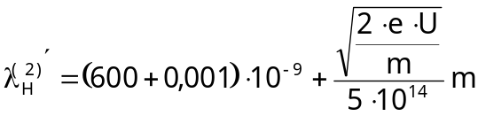 (8)

Considering the first energy level of the ion
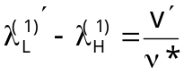 (9)
In this case
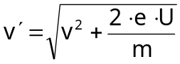
ν* = 5 . 10¹⁴ Hz
v = 6000 m/s
λ_{H}⁽¹⁾ = 600 . 10⁻⁹ m
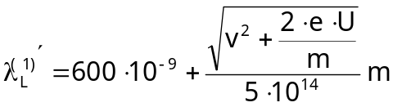 (10)

Substitute 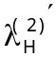 from (8) and 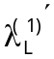 from (10) in (4) to get
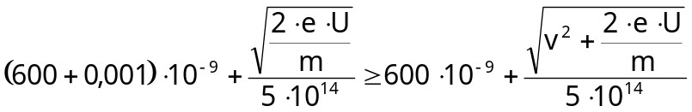

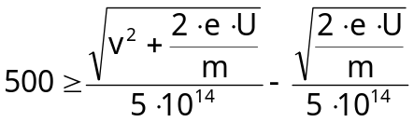

assume that U is of the order of 100 and over,
then 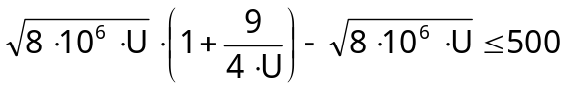
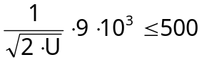
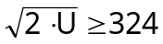
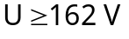

The minimum value of accelerating voltage to avoid overlapping of absorption spectra is approximately 162 V

Theory 2
Maxwell´s Wheel

Introduction
A cylindrical wheel of uniform density, having the mass M = 0,40 kg, the radius R = 0,060 m and the thickness d = 0,010 m is suspended by means of two light strings of the same length from the ceiling. Each string is wound around the axle of the wheel. Like the strings, the mass of the axle is negligible. When the wheel is turned manually, the strings are wound up until the centre of mass is raised 1,0 m above the floor. If the wheel is allowed to move downward vertically under the pulling force of the gravity, the strings are unwound to the full length of the strings and the wheel reaches the lowest point. The strings then begin to wound in the opposite sense resulting in the wheel being raised upwards.

Analyze and answer the following questions, assuming that the strings are in vertical position and the points where the strings touch the axle are directly below their respective suspending points (see fig. 19.5 a and b).

fig. 19.5

2.1
Determine the angular speed of the wheel when the centre of mass of the wheel covers vertical distance s.

2.2
Determine the kinetic energy of the linear motion of the centre of mass E_{r} after the wheel travels a distance s = 0,50 m, and calculate the ratio between E_{r} and the energy in any other form in this problem up to this point.

Radius of the axle = 0,0030 m

2.3
Determine the tension in the string while the wheel is moving downward.

2.4
Calculate the angular speed ω´ as a function of the angle Φ when the strings begin to unwind themselves in opposite sense as depicted in fig. 19.6.
Sketch a graph of variables which describe the motion (in cartesian system which suits the problem) and also the speed of the centre of mass as a function of Φ.

fig. 19.6

2.5
If the string can withstand a maximum tension T_{m} = 10 N, find the maximum length of the string which may be unwound without breaking by the wheel.

Solution

2.1
conservation of energy: 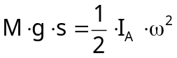 (1)
where ω is the angular speed of the wheel and I_{A} is the moment of inertia about the axis through A.

Note: If we would take the moment of inertia about S instead of A we would have
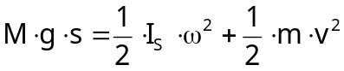
where v is the speed of the centre of mass along the vertical.
This equation is the same as the above one in meanings since
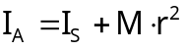 and 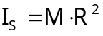
From (1) we get 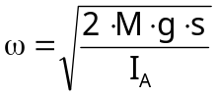
substitute 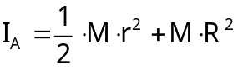
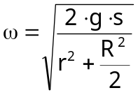
Putting in numbers we get
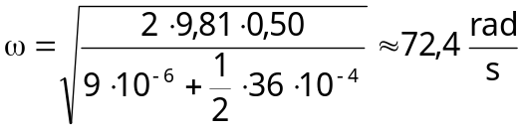

2.2
Kinetic energy of linear motion of the centre of mass of the wheel is
Potential energy of the wheel
Rotational kinetic energy of the wheel
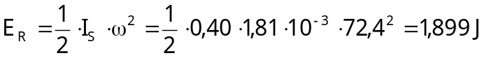
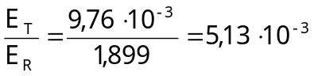

2.3
Let  be the tension in each string.
Torque τ which causes the rotation is given by 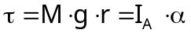
where α is the angular acceleration 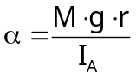
The equation of the motion of the wheel is M.g – T = M.a
Substitute a = α.r and we get
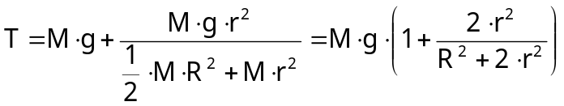
Thus for the tension in each string we get
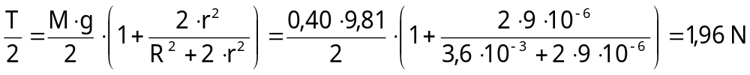

2.4

fig. 19.7

After the whole length of the strings is completely unwound, the wheel continues to rotate about A (which is at rest for some interval to be discussed).
Let 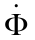 be the angular speed of the centre of mass about the axis through A.
The equation of the rotational motion of the wheel about A may be written as 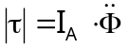,
where τ is the torque about A, I_{A} is the moment of inertia about the axis A and 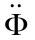 is the angular acceleration about the axis through A.
Hence 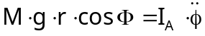
and 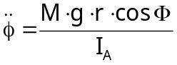
Multiplied with gives:
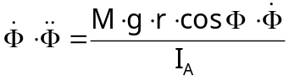
or
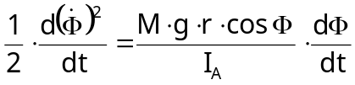
this gives
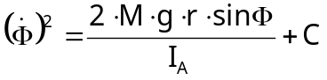 [C = arbitrary constant]

If Φ = 0 [s = H] than is 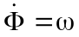
That gives 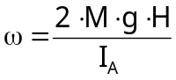 and therefore 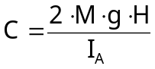
Putting these results into the equation above one gets

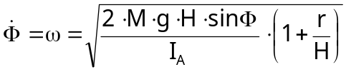

fig. 19.8

For 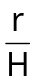 <<< 1 we get:
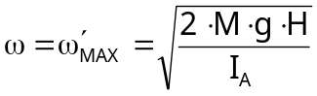 and 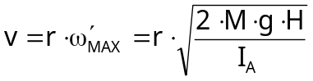

Component of the displacement
along x-axis is x = r.sin Φ-r
along y-axis is y = r.cos Φ-r

fig. 19.9

2.5
Maximum tension in each string occurs 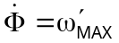

The equation of the motion is 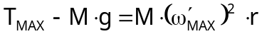
Putting in T = 20 N and 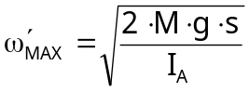 (where s is the maximum length of the strings supporting the wheel without breaking) and 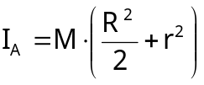 the numbers one gets:
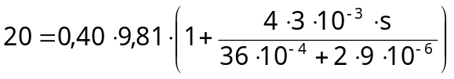
This gives: s = 1,24 m

The maximum length of the strings which support maximum tension without breaking is 1,24 m.

Theory 3
Recombination of Positive and Negative Ions in Ionized Gas

Introduction
A gas consists of positive ions of some element (at high temperature) and electrons. The positive ion belongs to an atom of unknown mass number Z. It is known that this ion has only one electron in the shell (orbit).

Let this ion be represented by the symbol A^{(Z-1)+}

Constants:
electric field constant 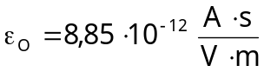
elementary charge 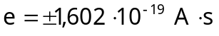
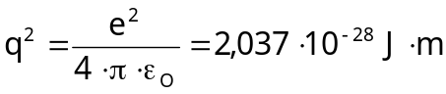
Planck´s constant 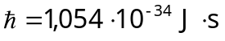
(rest) mass of an electron 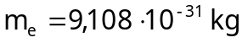
Bohr´s atomic radius 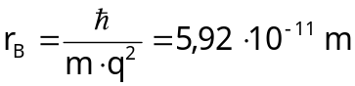
Rydberg´s energy 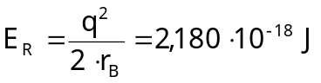
(rest) mass of a proton 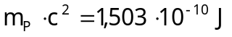

Answer the following questions:

3.1
Assume that the ion which has just one electron left the shell.
A^{(Z-1)+} is in the ground state.

In the lowest energy state, the square of the average distance of the electron from the nucleus or r² with components along x-, y- and z-axis being (Δx)², (Δy)² and (Δz)² respectively and 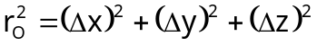 and also the square of the average momentum by 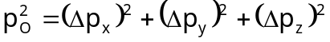, whereas 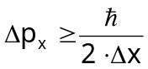, 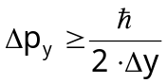 and 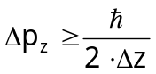.
Write inequality involving 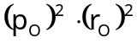 in a complete form.

3.2
The ion represented by A^{(Z-1)+} may capture an additional electron and consequently emits a photon.
Write down an equation which is to be used for calculation the frequency of an emitted photon.

3.3
Calculate the energy of the ion A^{(Z-1)+} using the value of the lowest energy. The calculation should be approximated based on the following principles:

A.
The potential energy of the ion should be expressed in terms of the average value of . (ie. 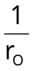; r₀ is given in the problem).

B.
In calculating the kinetic energy of the ion, use the average value of the square of the momentum given in 3.1 after being simplified by 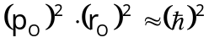

3.4
Calculate the energy of the ion A^{(Z-2)+} taken to be in the ground state, using the same principle as the calculation of the energy of A^{(Z-1)+} . Given the average distance of each of the two electrons in the outermost shell (same as r₀ given in 3.3) denoted by r₁ and r₂, assume the average distance between the two electrons is given by r₁+r₂ and the average value of the square of the momentum of each electron obeys the principle of uncertainty ie.
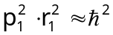 and 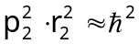

hint: Make use of the information that in the ground state r₁ = r₂

3.5
Consider in particular the ion A^{(Z-2)+} is at rest in the ground state when capturing an additional electron and the captured electron is also at rest prior to the capturing. Determine the numerical value of Z, if the frequency of the emitted photon accompanying electron capturing is 2,057 . 10¹⁷ rad/s. Identify the element which gives rise to the ion.

Solution

3.1
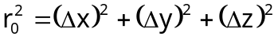
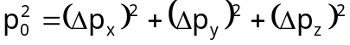
since
gives
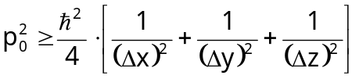
and
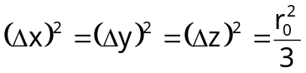
thus 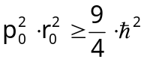

3.2
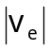...... speed of the external electron before the capture
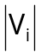....... speed of A^{(Z-1)+} before capturing
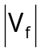 ...... speed of A^{(Z-1)+} after capturing
E_{n} = h.ν ...... energy of the emitted photon

conservation of energy:
where E[A^{(Z-1)+}) and E[A^{(Z-2)+}] denotes the energy of the electron in the outermost shell of ions A^{(Z-1)+} and A^{(Z-2)+} respectively.

conservation of momentum:
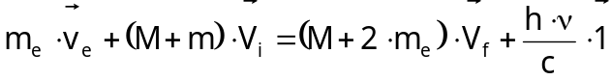
where is the unit vector pointing in the direction of the motion of the emitted photon.

3.3
Determination of the energy of A^{(Z-1)+} :
potential energy = 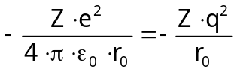
kinetic energy = 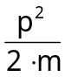

If the motion of the electrons is confined within the x-y-plane, principles of uncertainty in 3.1 can be written as
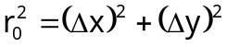
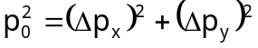
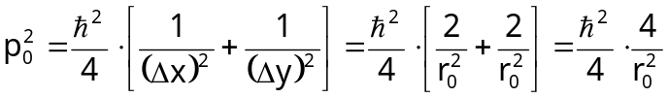
thus
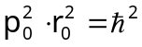

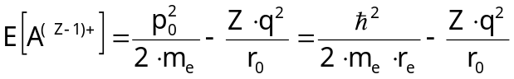

Energy minimum exists, when 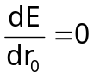.
Hence
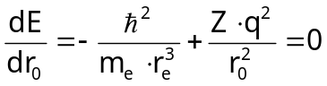
this gives 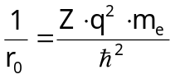
hence
3.4
In the case of A^{(Z-1)+} ion captures a second electron
potential energy of both electrons = 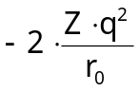
kinetic energy of the two electrons = 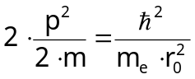
potential energy due to interaction between the two electrons = 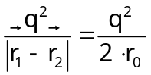
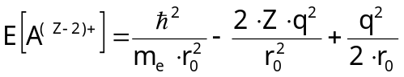

total energy is lowest when
hence
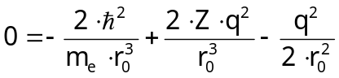
hence
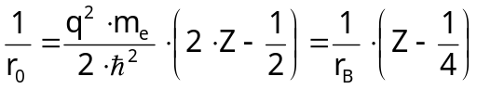

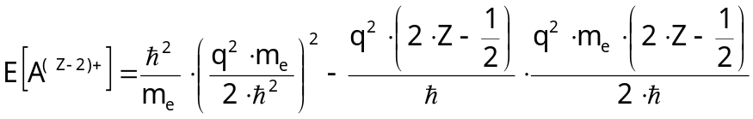

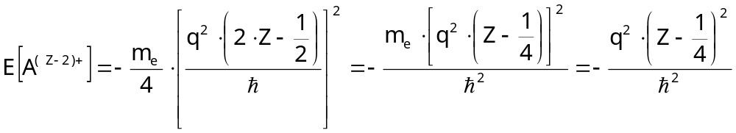
this gives
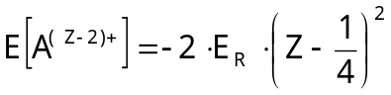

3.5
The ion A^{(Z-1)+} is at rest when it captures the second electron also at rest before capturing.
From the information provided in the problem, the frequency of the photon emitted is given by
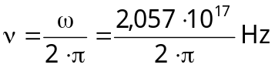
The energy equation can be simplified to 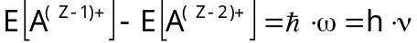
that is
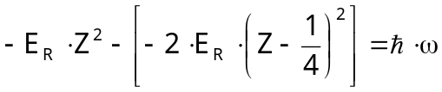
putting in known numbers follows
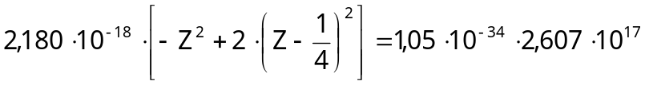
this gives
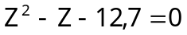
with the physical sensuous result
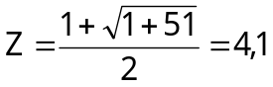
This implies Z = 4, and that means Beryllium

Experiments

Part 1: Polarized Light

General Information
Equipment:
- one electric tungsten bulb made of frosedt-surface glass complete with mounting stand, 1 set
- 3 wooden clamps, each of which contains a slit for light experiment
- 2 glass plates; one of which is rectangular and the other one is square-shaped
- 1 polaroid sheet (circular-shaped)
- 1 red film or filter
- 1 roll self adhesive tape
- 6 pieces of self-adhesive labelling tape
- 1 cellophane sheet
- 1 sheet of black paper
- 1 drawing triangle with a handle
- 1 unerasable luminocolour pen 312, extra fine and black colour
- 1 lead pencil type F
- 1 lead pencil type H
- 1 pencil sharpener
- 1 eraser
- 1 pair of scissors

Important Instructions to be Followed

- There are 4 pieces of labelling tape coded for each contestant. Stick the tape one each on the instrument marked with the sign #. Having done this, the contestant may proceed to perform the experiment to answer the questions.
- Cutting, etching, scraping or folding the polaroid is strictly forbidden.
- If marking is to be made on the polaroid, use the lumino-colour pen provided and put the cap back in place after finishing.
- When marking is to be made on white paper sheet, use the white tape.
- Use lead pencils to draw or sketch a graph.
- Black paper may be cut into pieces for use in the experiment, but the best way of using the black paper is to roll it into a cylinder as to form a shield around the electric bulb. An aperture of proper size may be cut into the side of the cylinder to form an outlet for light used in the experiment.
- Red piece of paper is to be folded to form a double layer.

The following four questions will be answered by performing the experiment:

Question 1.1

1.1.a
Locate the axis of the light transmission of the polaroid film. This may be done by observing light reflected from the surface of the rectangular glass plate provided. (Light transmitting axis is the direction of vibration of the electric field vector of light wave transmitted through the polaroid). Draw a straight line along the light transmission axis as exactely as possible on the polaroid film. (#)

1.1.b
Set up the apparatus on the graph paper for the experiment to determine the refractive index of the glass plate for white light.

When unpolarized light is reflected at the glass plate, reflected light is partially polarized. Polarization of the reflected light is a maximum if the tangens of incident angle is equal to the refractive index of the glass plate, or: tan α = n.
Draw lines or dots that are related to the determination of the refractive index on the graph paper. (#)

Question 1.2
Assemble a polariscope to observe birefringence in birefringent glass plate when light is normally incident on the plastic sheet and the glass plates.

A birefringent object is the object which splits light into two components, with the electric field vectors of the two components perpendicular to each other. The two directions of the electric field vectors are known as birefringent axes characteristic of birefringent material. These two components of light travel with different velocity.

Draw a simple sketch depicting design and functions of the polariscope assembled.

Insert a sheet of clear cellophane in the path of light in the polariscope. Draw lines to indicate birefringent axes (#). Comment briefly but concisely on what is observed, and describe how berefringent axes are located.

Question 1.3

1.3.a
Stick 10 layers of self-adhesive tape provided on the glass plate as shown below. Make sure that each layer recedes in equal steps.

fig. 19.10

G square glass plate as a substrate for the cellophane layers
T 10 layers of cellophane sheet
S steps about 3 mm up to 4 mm wide

Insert the assembled square plate into the path of light in the polariscope. Describe conditions for observing colours. How can these colours be changed ? Comment on the observations from this experiment.

1.3.b
Prepare monochromatic red light by placing doubly-folded red plastic sheet in the path of white light. Mark on the assembled square plate to show the steps which allow the determination of the difference of the optical paths of the two components of light from berefringent phenomenon, described under 1.2 (#).
Estimate the difference of the optical paths from two consecutive steps.

Question 1.4

1.4.a
With the polariscope assembled, examine the central part of the drawing triangle provided. Describe relevant optical properties of the drawing triangle pertaining to berefringence.

1.4.b
Comment on the results observed. Draw conclusions about the physical properties of the material of which the triangle is made.

Additional Cautions

Be sure that the following items affixed with the coded labels provided accompany the report.
- (#) Polarized film with the position of the transmission axis clearly marked.
- (#) Graph paper with lines and dots denoting experimental setup for determining refractive index.
- (#) Sheet of cellophane paper with marking indicating the positions of birefringent axis.
- (#) Square glass plate affixed with self-adhesive tape with markings to indicate the positions of birefringent axis.

Solution

In this experiment the results from one experimental stage are used to solve problems in the following experimental stages. Without actually performing all parts of the experiment, solution cannot be meaningfully discussed.

It suffices that some transparent crystals are anisotropic, meaning their optical properties vary with the direction. Crystals which have this property are said to be doubly refracting or exhibit birefringece.

This phenomen can be understood on the basis of wave theory. When a wavefront enters a birefringent material, two sets of Huygens wavelets propagate from every point of the entering wavefront causing the incident light to split into two components of two different velocities. In some crystals there is a particular direction (or rather a set of parallel directions) in which the velocities of the two components are the same. This direction is known as optic axes. the former is said to be uniaxial, and the latter biaxial.

If a plane polarized light (which may be white light or monochromatic light) is allowed to enter a uniaxial birefringed material, with its plane of polarization making some angle, say 45° with the optic axis, the incident light is splitted into two components (ordinary and extraordinary) travelling with two different velocities. Because of different velocities their phases different.

Upon emerging from the crystal, the two components recombine to from a resultant wave. The phase difference between the two components causes the resultant wave to be either linearly or circularly or elliptical polarized depending on the phase difference between the two components. The type of polarization can be determined by means of an analyser which is a second polaroid sheet provided for this experiment.

Problem 2
Electron Tube

Introduction
Free electrons in a metal may be thought of as being “electron gas” confined in potential or energy walls. Under normal conditions or even when a voltage is applied near the surface of the metal, these electrons cannot leave the potential walls (see fig. 19.11)
If however the metal or the electron gas is heated, the electrons have enough thermal energy (kinetic energy) to overcome the energy barrier W (W is known as “work function”). If a voltage is applied across the metal and the anode, these thermally activated electrons may reach the anode.
The number of electrons arriving at the anode per unit time depends on the nature of the cathode and the temperature, i.e. all electrons freed from the potential wall will reach the anode no longer increase with applied voltage (see fig. 19.11)
The saturated current corresponding to the number of thermally activated electrons freed from the metal surface per unit time obeys what is generally known as Richardson´s equation i.e.

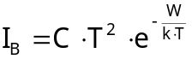

where
C is a constant
T temperature of the cathode in Kelvin
k Boltzmann´s constant = 1,38 . 10⁻²³ J/K

fig. 19.11

fig. 19.12

fig. 19.13

Determine the value of the work function W of tungsten metal in the form of heating filament of the vacuum tube provided.

The following items of equipment are placed at the disposal of the contestants:
- Electron tube AZ 41 which is a high-vacuum, full-wave rectifying diode. The cathode is made from a coated tungsten filament the work function of which is to be ascertained. According to the manual prepared by its manufacturer, no more than 4 V should be used when applying heating current to the cathode. Since the tube has two anodes, it is most desirable to have them connected for all measurements. The diagram in fig. 19.14 is a guide to identifying the anodes and the cathode.

fig. 19.14

- multimeter 1 unit, internal resistance for voltage measurement: 10 MΩ
- battery 1,5 V (together with a spare)
- battery 9 V; four units can be connected in series as shown in fig. 19.15
- connectors
- resistors; each of which has specifications as follows:
1000 Ω ± 2% (brown, black, black, brown, brown, red)
100 Ω ± 2% (brown, black, black, black, brown, red)
47,5 Ω ± 1% (yellow, violet, green, gold, brown)
- resistors; 4 units, each of which has the resistance of about 1 Ω and coded
- connecting wires
- screw driver
- graph paper (1 sheet)
- graph of specific resistance of tungsten as a function of temperature; 1 sheet

fig. 19.15

Solve the following problems:

2.1
Determine the resistance of 4 numerically-coded resistors. Under no circumstances must the multimeter be used as an ohmmeter.

2.2
Determine the saturated current for 4 different values of cathode temperatures, using 1,5 V battery to heat the cathode filament. A constant value of voltage between 35 V – 40 V between the anode and the cathode is sufficient to produce a saturated current. Obtain this value of voltage by connecting the four 9 V batteries in series. Describe how the different values of temperature are determined.

2.3
Determine the value of W. Explain the procedures used.

fig. 19.16

Solution

2.1
Connect the circuit as shown in fig. 19.17

fig. 19.17

R_{X} .... resistance to be determined
R ...... known value of resistance

Measure potential difference across R_{X} and R. Chose the value of R which gives comparable value of potential difference across R_{X}.

In this particular case R = 47,5 Ω

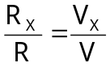

where V_{X} and V are values of potential differences across R_{X} and R respectively.
R_{X} can be calculated from the above equation.
(The error in R_{X} depends on the errors of V_{X} and V_{R}).

2.2
Connect the circuit as shown in fig. 19.18

fig. 19.18

- Begin the experiment by measuring resistance R₀ of the tungsten cathode when there is no heating current
- Add resistor R = 1000 Ω into the cathode circuit, determine resistance R₁ of the tungsten cathode, calculate the resistance of the current-carrying cathode.
- Repeat the experiment, using the resistor R = 100 Ω in the cathode circuit, determine resistance R₂ of tungsten cathode with heating current in the circuit.
- Repeat the experiment, using the resistor R = 47,5 Ω in the cathode circuit, determine resistance R₃ of tungsten cathode with heating current in the circuit.
- Plot a graph of 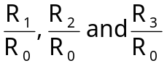 as a function of temperature, put the value of 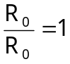 to coincide with room temperature i.e. 18°C approximately and draw the remaining part of the graph parallel to the graph of specific resistance as a function of temperature provided in the problem. From the graph, read values of the temperature of the cathode T₁, T₂ and T₃ in Kelvin.

fig. 19.19

From the equation 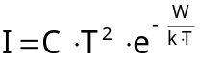
we get 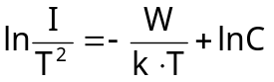

Plot a graph of 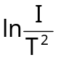 against .
The curve is linear. Determine the slope m from this graph. 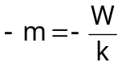

Work function W can be calculated using known values of m and k (given in the problem).

Error in W depends on the error of T which in turn depends on the error of measured R.

